Chapter 6

**Friction (6.1)**

* When an object is sliding along a surface, it will encounter a resistance force called friction. It is directly parallel to the sliding force.
* If there is no movement, the frictional force is called static friction
* To move an object across any given surface, there must be a greater force provided to overcome the frictional force.
* 
* μs : the friction coefficient and is different for every object
* Normal force - is that component of the contact force that is perpendicular to the surface that an object contacts

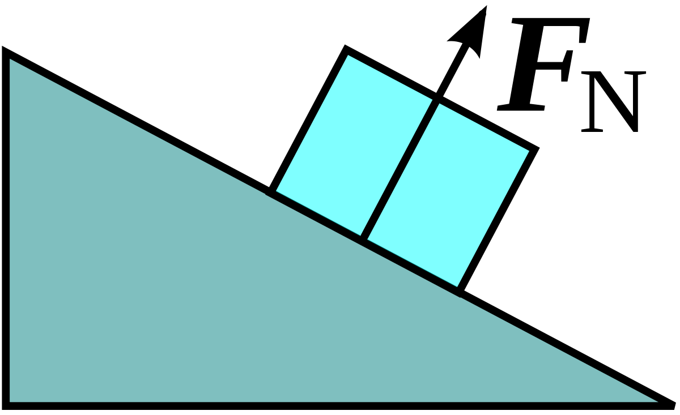

* When the particle overcomes the frictional force, the magnitude of the frictional force rapidly decreases to a constant value given by :



Chapter 7

**Kinetic Energy (7.1)**

* Energy associated with motion of a particle given :



**Work and Kinetic Energy (7.2)**

* Work is the energy transferred to or from an object via a force
* 
* Only the x component actually does work on an object (**horizontal motion**)
* When multiple forces act upon an object, the total net work is the sum of those forces. This equal to the work done by the Fnet of the forces
* For a particle, a change in kinetic energy equals the net work done on the particle:
* 
* A great [Chegg study article](https://www.chegg.com/homework-help/questions-and-answers/figure-horizontal-force-magnitude-180-n-applied-283-kg-book-book-slides-distance-d-052-m-f-q6004929) on this

**Work done by the Gravitational Force (7.3)**

* The work done by gravity on a particle like object with a mass *m* is given by:
* 
* The work Wa done by an applied force (acceleration) as a particle like object is either **lifted or lowered** is related to the Wg (gravitational force work) is represented as :
* 

**Work done by a Spring Force (7.4)**

* The spring force is represented as :
* 
* K is the spring constant
* D is the displacement from where the spring was released to where it is in a relaxed state. This can also be written with respect to the x axis :
* 
* Spring Force is variable depending on the displacement
* If the spring is observed with respect to an initial and final position, it can be represented as :
* 
* If initial is 0 and final is some variable x, the equation becomes :
* 
* The equation can then be integrated with respect to x from 0 to x.

**Work done by a General Variable Force (7.5)**

* When the force on a particle-like object depends on the position of the object, the work done by the force while the object is in coordinate plane (vector notation), the work done is found by integrating each component : 
* Only integrate the components that are given

**Power (7.6)**

* The power due to a force is the rate at which that force does work on the object
* If the force does work *W* during a time interval, the average power due to the force over that time interval is :
* 
* Instantaneous power is the instantaneous rate of doing work : 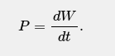
* The force F at an angle to the direction of travel of the instantaneous velocity, the instantaneous power is :
* 

Summary : ~~Particles in motion have energy called kinetic energy which similar to Newton’s 2nd law (F = ma) where the KE needs a given velocity and mass of the object.~~

~~Work being done upon an object is the energy transferred to and from an object, which can be found by the angle, mass and the displacement of the object. The work energy theorem states that the average kinetic energy is equal to the work done.~~

Chapter 8

**Potential Energy (8.1)**

* Potential Energy - energy that has accumulated but has not been released
* Conservative Force : The work done by a force only depends on the initial position and the final position, not the path taken.
* The gravitational force is a conservative force
* The energy in a system is conserved via a conservative force
* Friction is not a conservative force, energy is transformed into thermal energy and is dissipated into the block or surface.
* The change in potential energy is negative work (**horizontal work**):
* 
* Find the total potential energy by integrating the function along the x-axis (**horizontal motion**) :



* Find the potential energy along the y axis by taking gravity into account : 
* Potential energy at any specified height *y* with the gravitational constant :  Derived from **F = ma**
* Elastic Potential Energy :

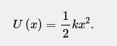 Similar to kinetic energy (1/2mv^2)

**Conservation of Mechanical Energy (8.2)**

* Mechanical Energy is the sum of its kinetic energy and potential energy
* 
* If there are no external forces and the system is closed , the energy cannot be lost :



**Reading a Potential Energy Curve (8.3)**

* We can find the force of a particle by taking the first derivative of the given function (one dimensional) :



* If U(x) is given on a graph, then at any value of x, the force F(x) is the negative of the slope of the curve there and the kinetic energy of the particle is given by : 
* The turning point of the graph would be the reverse of motion of a particle
* The particle is in equilibrium at points where the slope of the U(x) curve is zero (where F(x) == 0)

**Work Done on a System by an External Force (8.4)**

* Work is the energy transferred to or from a system by means of an external force acting on the system
* When more than one force acts on a system, their net work is the transferred energy
* When friction is not involved, the work done on the system, the work done on the system and the change of mechanical energy of the system are equal : 
* When a kinetic frictional force acts within the system, then the thermal energy of the system changes. This is the energy associated with the random movement of atoms and molecules in the system) :



* The change in thermal energy is related to the magnitude d of the displacement caused by the external force by :



**Conservation of Energy (8.5)**

* The total energy E of a system (the sum of all energy) can change only by amount of energy that are transferred to and from the system. **Law of conservation of energy** :



* The power due to a force is the rate at which that force transfers energy : 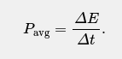
* Instantaneous power due to a force :

